**Contents:**

**1.** **Introduction:** 2

**2.** **Origins in Early Christianity:** 2

**3.** **Divergence Between Eastern and Western Christianity:** 3

**4.** **Development of Epiphany Traditions Worldwide:** 3

**5.** **Conclusion:** 3

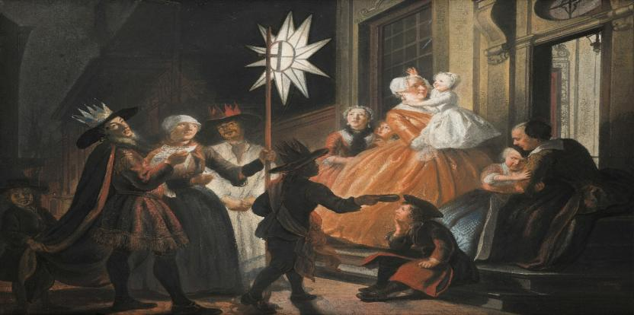

# **Introduction:**

Epiphany, celebrated on January 6, is one of the most ancient and meaningful feasts in the Christian calendar. Rooted in both biblical narrative and centuries of tradition, Epiphany commemorates the manifestation of Jesus Christ to the world. For Western Christians, it primarily marks the visit of the Magi—the Three Wise Men—while for Eastern Christians, it celebrates the Baptism of Jesus in the Jordan River. Though observed differently across cultures and denominations, Epiphany consistently highlights the universal mission of Christ and His revelation as the Son of God. This feast has shaped theology, liturgy, and tradition across centuries, reflecting its deep spiritual and historical significance.

# **Origins in Early Christianity:**

Epiphany is one of the oldest Christian feast days, with roots in the 2nd and 3rd centuries. Originally, it was celebrated primarily in the Eastern Church (Egypt, Syria, Asia Minor) as a combined commemoration of Jesus’ birth, baptism, and first miracle at Cana—all seen as early manifestations (epiphanies) of His divinity. n these early traditions, January 6 was seen as the day Jesus was revealed to the world.

# **Divergence Between Eastern and Western Christianity:**

As Christian traditions spread and evolved, the meaning of Epiphany diverged:

* Western Christianity (Roman Catholic and Protestant traditions) narrowed its focus to the visit of the Magi (Wise Men) from the East, symbolizing the revelation of Jesus to the Gentiles.
* Eastern Christianity (especially Eastern Orthodox) emphasizes the Baptism of Christ in the Jordan River, considering it the first clear manifestation of the Trinity—Jesus (the Son), the Holy Spirit descending like a dove, and the voice of the Father.

# **Development of Epiphany Traditions Worldwide:**

Epiphany has inspired a rich variety of cultural customs and religious rituals across the globe:

* Spain & Latin America: Known as El Día de los Reyes Mago’s, children receive gifts on January 6. Parades feature the Three Kings distributing sweets.
* France: The Galette des Roi’s, a puff pastry cake with a hidden fava (figurine), is shared. The one who finds it is crowned king/queen for the day.
* Italy: Epiphany is associated with La Bafana, a folklore figure who brings gifts to children.

# **Conclusion:**

The Feast of Epiphany is far more than a historical commemoration; it is a spiritual milestone that emphasizes revelation, inclusion, and divine purpose. Whether through the symbolic gifts of the Magi, the descent of the Holy Spirit at Jesus’ baptism, or the joyous global traditions that surround the day, Epiphany calls believers to recognize and respond to the light of Christ in the world. Its enduring celebration across cultures and Christian branches reminds us that the message of Jesus transcends boundaries—offering hope, guidance, and salvation to all.